Darwin Huang, [huang7@cooper.edu](mailto:huang7@cooper.edu)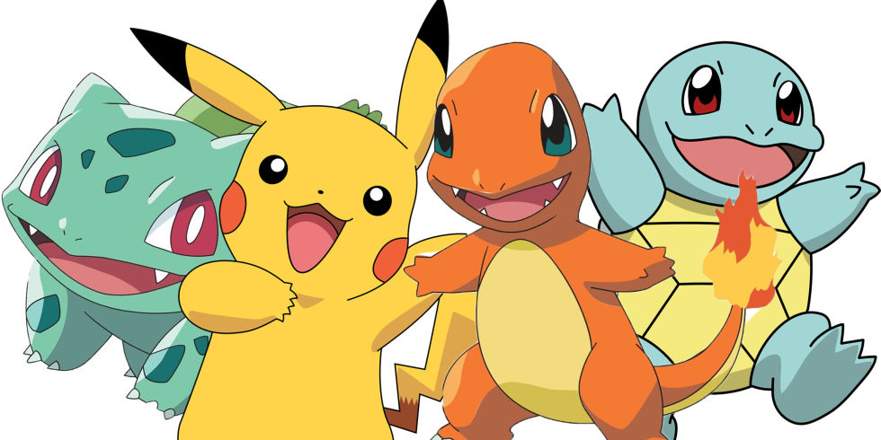

Eric Mendoza-Conner [mendoz@cooper.edu](mailto:mendoz@cooper.edu)

Sebastien Charles [charle5@cooper.edu](mailto:charle5@cooper.edu)

Professor Carl Sable ECE464: Databases

Games/TV Database

The purpose of the project is to create a database for Pokemon enthusiasts, who either watch the TV episodes or play the video games in the Pokemon franchise. This database will serve to provide these enthusiasts with a centralized location for Pokemon information. It will allow people to find good Pokemon to use if matching up against a Pokemon shown in the TV show, or simply against a friend’s preferred Pokemon. It will also help them find TV episodes starring their favorite Pokemon, or prepare to replicate teams found in TV in the Pokemon games. Essentially, the project aims to provide another great resource for all Pokemon fans.

The database will be able to direct a user looking for a Pokemon in action to the episodes in which it appears, or alternatively to provide all Pokemon in specific episodes or seasons. It will also hold all types, moves, and abilities of all Pokemon, so that a user could find good Pokemon to use against friends or foes, or simply against those Pokemon found in the TV show. Users will most likely be Pokemon enthusiasts, who enjoy watching associated TV shows or playing games. They may play Pokemon competitively, sing the Pokemon theme songs at karaoke, binge-watch Pokemon on the weekends, or be anyone else interested in Pokemon.

There will be two types of users in the database: high level (aka administrative) users and (aka visitor) low level users. High level users can modify or add Pokemon to a database while low level users can only access information in a read-only format. The only difference in the application from the perspective of each user is that high level users will see an “add” or “edit” button on the main site to add Pokemon or tv episodes and relevant information to that Pokemon or episode. The interface will allow all types of users to sort TV show titles by chronological order, and to sort Pokemon by type, season(s) of appearance in TV, etc. The user will be able to enter a Pokemon, and receive all TV episode(s) in which it appears, as well as all Pokemon types which are super effective or not very effective against it. The user will also be able to enter a TV episode, and receive all Pokemon that appear in the episode. The user should also be able to search for Pokemon with specific traits such as moves, stats or abilities.

We will populate the database by crawling the websites bulbapedia and pokemondb which each contain a subset of the data we are going to use for our database. Once populated, new data can be added manually to the database in case a new Pokemon is revealed, or in case the administrator(s) wish to add fake Pokemon for fun/testing. The interface will be an online web application that is both easy to navigate and densely populated with useful information for Pokemon enthusiasts.

The stored data will consist of information about every Pokemon from Generation I to Generation VI, including the moves they can learn, their types, and episodes in the TV Show they may have appeared in. Generation VII Pokemon will and can be added to the database after the release of information about those Pokemon and during demos of adding to the database. For example, in SQL terms, the database will store:

SQL Setup

Episode(EpisodeId: integer, EpisodeName: char(150), Season: integer, ReleaseDate: date)

AppearsIn(FK_PokemonId: integer, FK_EpisodeId: integer)

Pokemon(PokemonId: integer, HP: integer, Attack: integer, Defense: integer, Special Attack: integer, Special Defense: integer, Speed: integer, Name: char(20))

Learns(FK_PokemonId: integer, FK_MoveId: integer, atLevel: integer)

Moves(MoveId: integer, Power: integer, Accuracy: integer, Name: char(20))

Ability(AbilityId: integer, Name: char(20), Effect: char(20))

Possesses(FK_PokemonId: integer, FK_AbilityId: integer)

has(FK_PokemonId: integer, FK_TypeId: integer)

is(FK_MoveId: integer, FK_TypeId: integer)

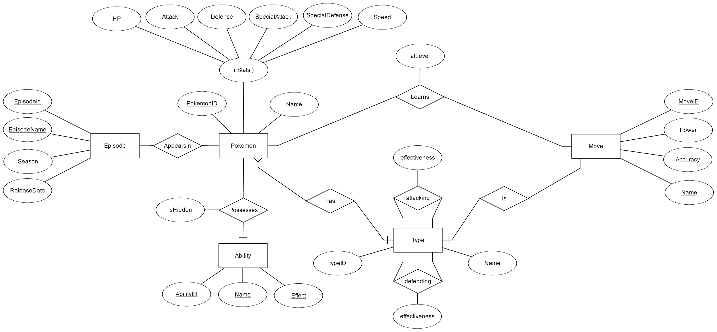

**Legend for the ER diagram**

|  |  |
| --- | --- |
|  | Indicates that the entity can have one or more of this relationship |
|  | Indicates a total participation constraint |
|  | Represents an entity set |
|  | Represents an attribute |
|  | Represents a relationship |
|  | Represents a key attribute |